# **Stunt Crasher by BoneCracker Games**

Thank you for purchasing Stunt Crasher! You can add your own vehicles, levels, obstacles, ui elements, scenes and reskin the game with your imagination. This documentation will guide you how to do them in shortest and cleanest ways.

# **Package includes**

* Car controller with audio, particles, damage, skidmarks, and more,
* Upgradable cars with engine, boost, and bonus multiplier,
* Destructible 3 player cars with individual parts such as hood, trunk, doors, wheels, and more,
* Customizable 3 individual scenes,
* 8 Prop models (With LOD) and 5 scene environments such as big stadium, forest, and more,
* Global shared settings manager,
* Complete out of box project ready to build for any platform. Tested on Android, iOS, WebGL, and Windows.
* Full functional demo with given assets.

# Editor Extensions Features;

* Creating new levels and their new obstacles
* Creating new player vehicles
* Editing shared settings

Table of Contents

**Stunt Crasher by BoneCracker Games** 1

**Package includes** 1

Editor Extensions Features; 1

First to Do! 3

Importing Project Settings Manually 5

All Resources 6

How To Add New Levels 7

Manager Scripts 8

_GameManager 8

_InputManager 9

_Camera 9

_Launcher 9

_Finisher 9

_Obstacle 9

How To Add New Vehicles 10

How To Add Obstacles / Props 11

How To Change Controller Type 12

Testing Panel 13

PostProcessing Image Effects and URP 14

# First to Do!

Before importing the package, be sure your active platform is your target platform. Open “**Build Settings**” and switch platform to your target platform before importing the package. This will save your time.

After importing process, please check your “**Tags & Layers**” and “**Build Settings**” before using the package. Your “**Tags & Layers**” and “**Build Settings**” must be exactly same with this;

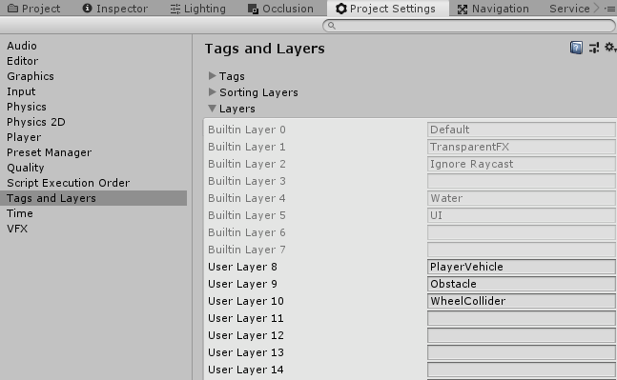

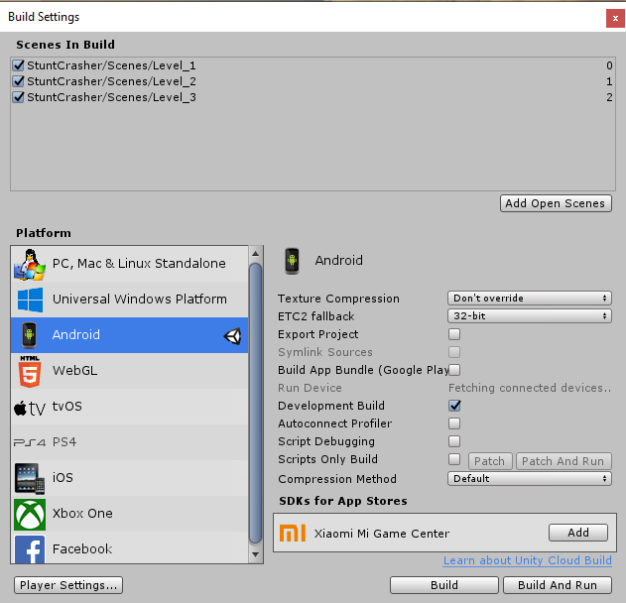

**(If your Project Settings are not imported as seen in screenshot, you have to import Project Settings manually)**

This game is using “**Portrait**” display mode. Therefore, you must set your display mode to any portrait mode in your editor.

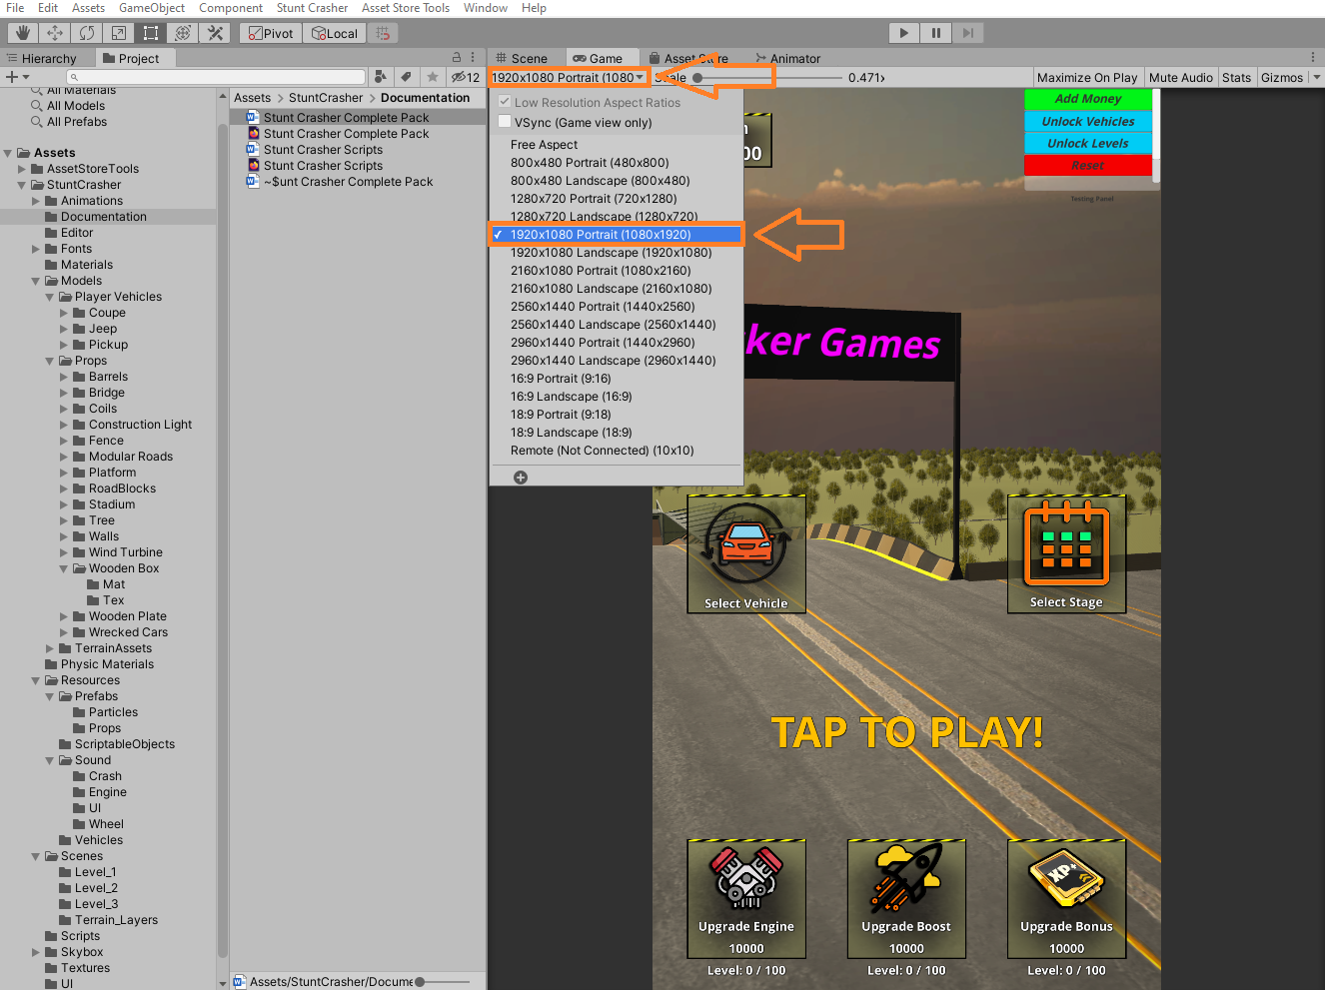

UI canvas supports all aspect ratios, but actually designed for portrait modes. Just be sure your default orientation is same with your display mode.

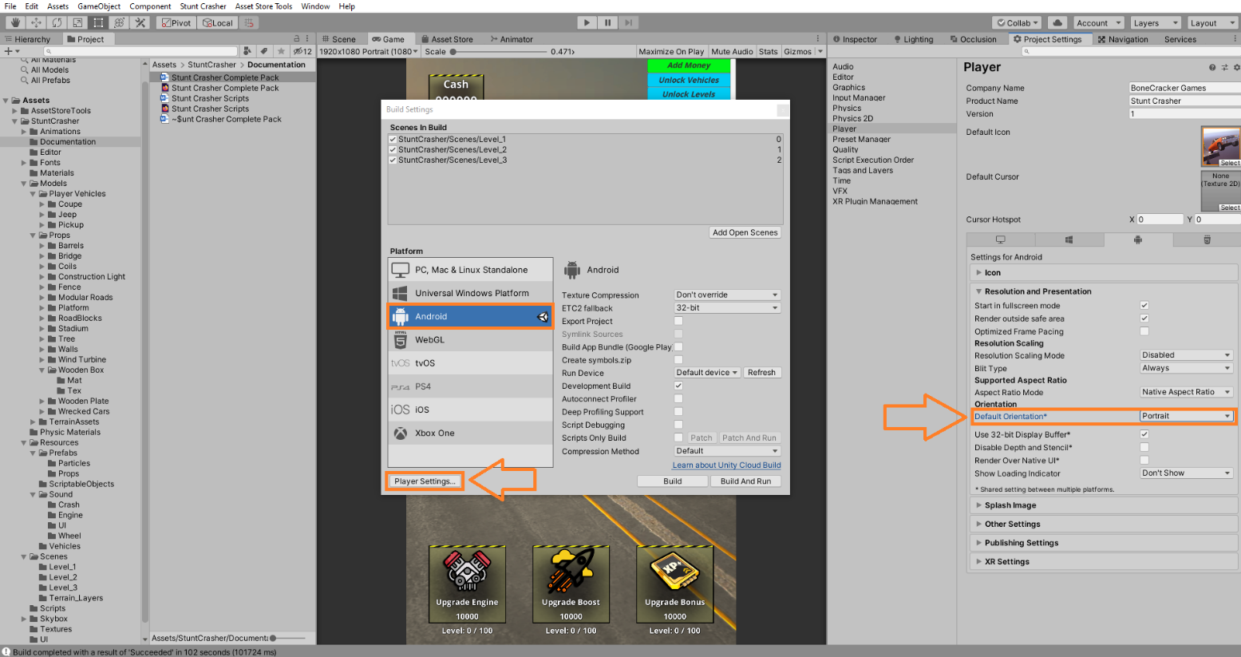

# Importing Project Settings Manually

(If your Project Settings are imported successfully, you can skip this step)

After importing the package, close your Unity Editor and open “**ProjectSettings**”compressed rar file inside “**Assets**”. You will find “**ProjectSettings**” folder at root of your project. Extract all folders into this folder. Replace any existing file. This folder contains all necessary tag & layers and all kind of necessary project settings for your editor. You may get an error about layout when you fired up Unity. Just click “**LoadDefaultLayout**” in this case.

You can find all shared settings in **Stunt Crasher 🡪 Edit Settings**.

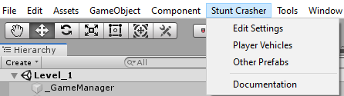

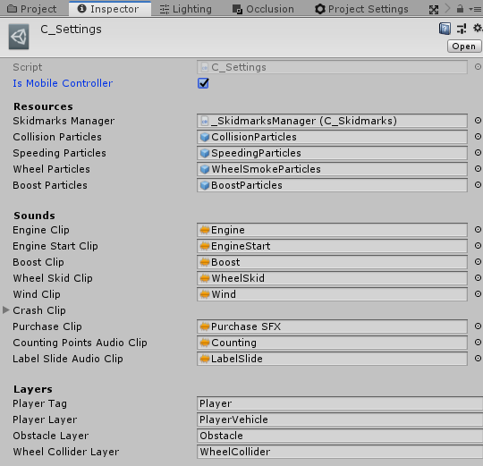

You can edit all shared global settings here.

# All Resources

All player vehicles, all weapons, all enemies, all props, and all other resources are located in a scene named “**Level_Resources**”. Before reskining the game or editing things, I would recommend you to take a look at this scene and check out vehicles, props, and all other resources. This would be very useful information that you gonna use in future.

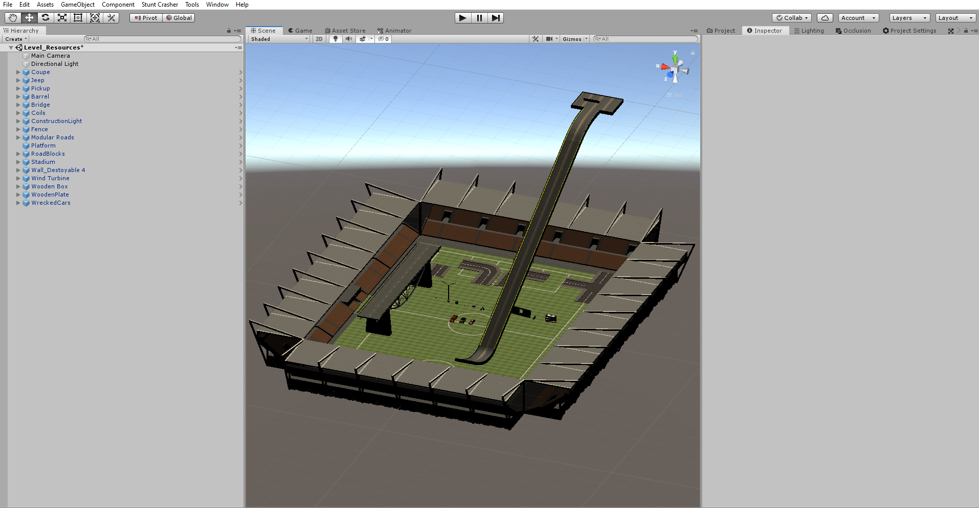

# How To Add New Levels

Shortest way to create your own scene, is duplicate one scene and edit the scene whatever you like. For ex, if you want to create a new level, duplicate current scene as reference, then customize your scene. And add your new scene to your Build Settings. But it’s ok if you want to start from scratch. Be sure your own scene has necessary manager scripts, UI, Camera, and other equipments. Each scene must have these manager gameobjects;

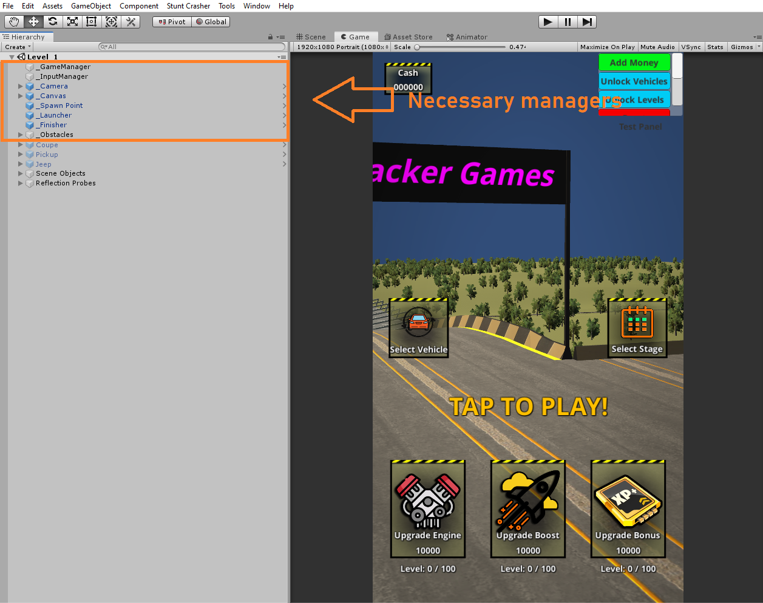

Go to your “**Build Settings**”, and add your new level to the list. All scenes must be added in Build Settings.

# Manager Scripts

## _GameManager

Controls overall behavior of the scene. Spawns player vehicles, controls UI, calculates score, starts and finishes the level, purchases new vehicles, upgrade them, etc... Each method in C_GameManager.cs is well and fully documented. Hardcode free and very easy to edit.

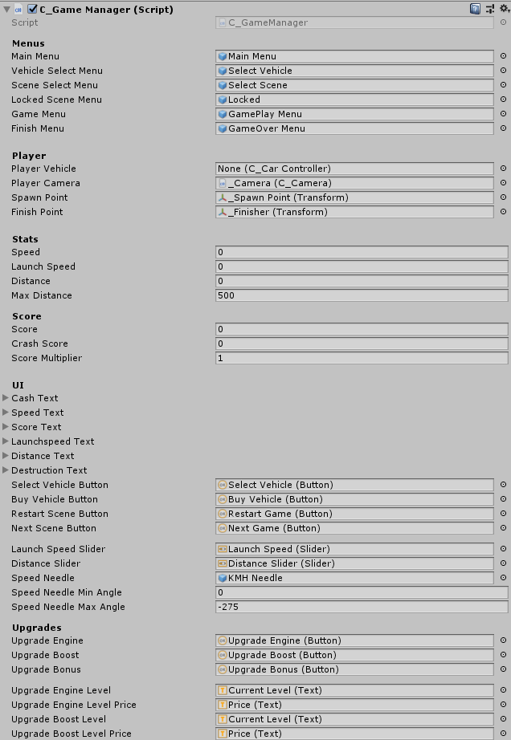

## _InputManager

Gets input from axis or UI button. C_CarController is using "motorInput" variable in this script. If mobile controller is enabled, takes input from UI. If disabled, takes input from Input.GetAxis().

## _Camera

Player camera that follows player vehicle with desired settings. Distance, height, field of view angles, rotation or position offsets can be changed.

## _Launcher

Launch position. Create a trigger collider and attach this script. Calls "Launch()" method in C_GameManager script when player triggers with it. It’s simply a box trigger.

## _Finisher

Finish position. Create a trigger collider and attach this script. Enables “**gameCompleted**” bool in C_GameManager script when player triggers with it. It’s simply a box trigger.

## _Obstacle

Obstacle with score, name, etc...    If player vehicle collides with an object including this script, it will add score. Score and name of the obstacle can be changed.

# How To Add New Vehicles

All of your vehicles must have “**C_CarController**” script for operating the car. Also handles player score, upgrades, and stats too. Just one script per vehicle handles everything.

**1 –** Drag and drop your vehicle model to your scene.

**2 –** Be sure your vehicle model has correct X Y Z axes and directions. Z must be facing forward. X is right, and Y is up. This is the golden rule of 3D modeling.

**3 –** Select your vehicle and click **Stunt Crasher 🡪 Add 🡪 Car Controller**.

**4 –** This will add Rigidbody and **C_CarController** component to your vehicle with default settings and resources.

**5 –** Select all wheels of your vehicle and click “**Create WheelColliders**” button. This will create wheelcolliders with proper dimensions and radius.

**6 –** Be sure your vehicle has body collider. If your vehicle has no any type of collider, it will fall down through the ground and behave glitchy.

**7 –** Technically, your new vehicle is ready to use in the game. Click “**Add it to Vehicles List**” button to creating a new prefab and adding it to player vehicles list as playable vehicle. This will create a new prefab in “**Assets\Stunt Crasher\Resources\Vehicles**” folder. As you can see, all vehicle prefabs are in this folder.

**8 –** If your vehicle has individual physical parts like hood, bumpers, doors, fenders, trunk, you must add “**Configurable Joints**” or “**Fixed Joints**” to them. Be sure you are using correct setup per each parts. Also you can set strength of the parts too. Depending on collision force, part will be broken.

**9 –** Go to **Stunt Crasher 🡪 Player Vehicles** and check all vehicles. You can set their price and sort by new order. Typing price as “**0**”will make this vehicle will be unlocked as default.

Now, you have created a new vehicle and stored it as prefab in your project. All you need to do is add the prefab to your selectable player vehicles list. Open up “**Player Vehicles**” window from **Stunt Crasher 🡪 Player Vehicles**.

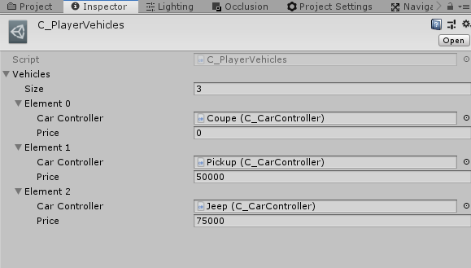

Also you can set its price, unlocked or not, etc...

After doing this, check out your car selection menu on Main Menu. Your new vehicle must be visible and selectable now. There are no needed additional things for creating new vehicles. If you are not satisfied with your vehicle setup, you can edit and apply prefab changes at the end.

# How To Add Obstacles / Props

Each obstacle is a prefab.All obstacles in game are located in “**Resources 🡪 Prefab 🡪 Props**” folder. Each obstacle must have “**Obstacle**” component attached to it. You can change their names and score as you wish. If player vehicle collides with an object with “**Obstacle**” component, player will earn score.

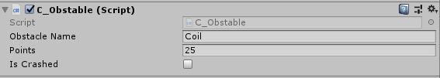

# How To Change Controller Type

You can change controller type from **Stunt Crasher 🡪 Edit Settings 🡪 Controller.**



All mobile UI controllers will be visible if you choose “**Mobile**”. They are not visible and functional if your controller type is not mobile controller.

# Testing Panel

Testing panel is disabled by default. But you can enable and use it by editing UI canvas prefab. In order to do this, you will need to open the prefab named “Canvas” in Resources / Prefabs folder. Open the prefab and enable “Testing Panel” parented to the canvas. Save after editing. All of your scenes will have testing panel enabled and functional.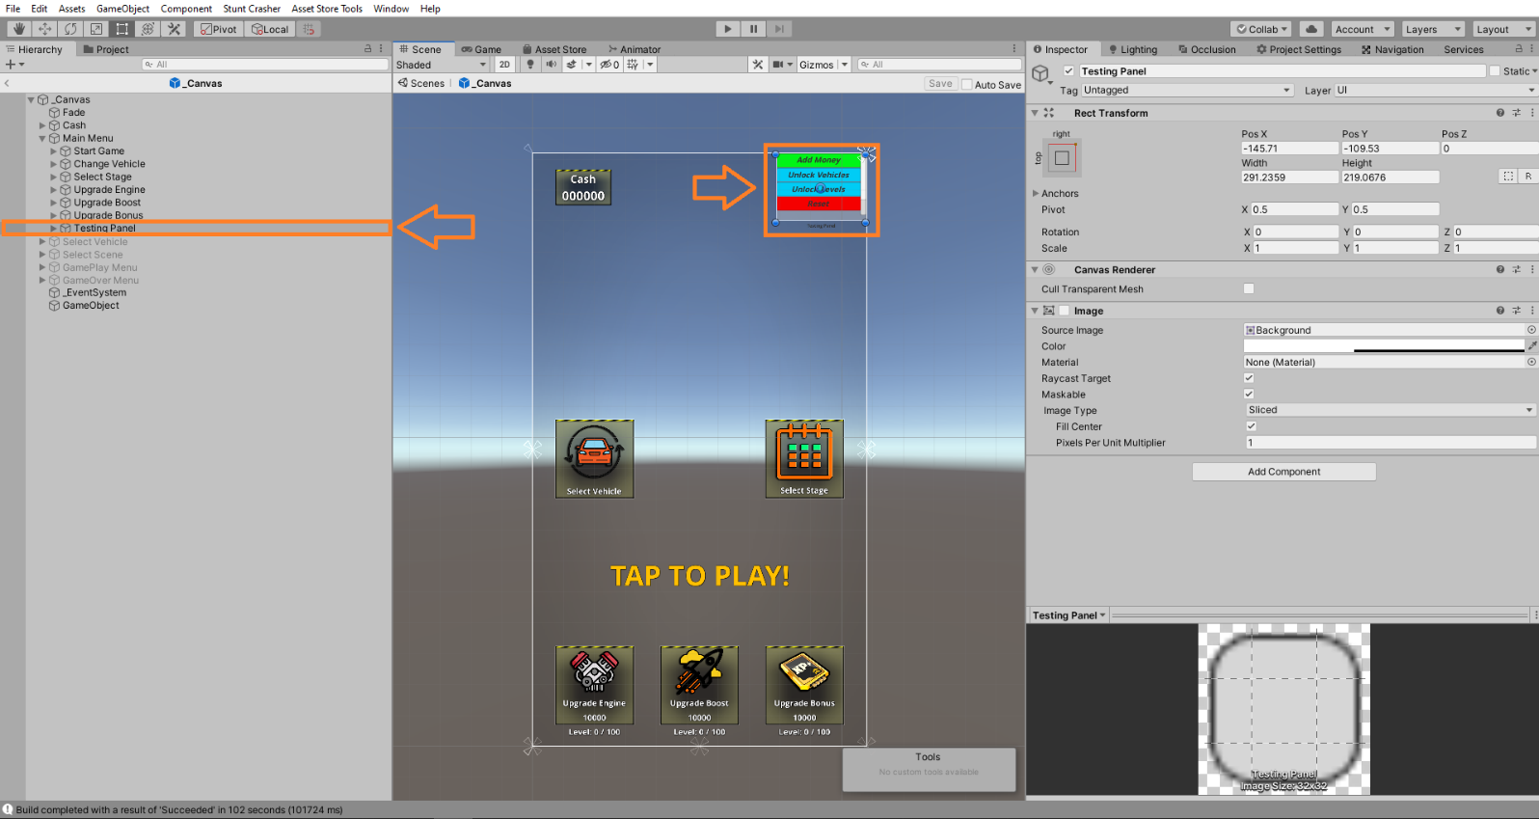

# PostProcessing Image Effects and URP

PC and WebGL demos have **Post Processing image effects**. Most mobile devices can’t handle it. Post Processing is defaultly disabled. But you can import latest version from Unity Asset Store. Also project doesn’t use any custom shaders. So, you can use URP in this project without any issue.

I tried to keep the project clean, smooth, and understandable. If you have any questions, or requests, please contact me on;

**BoneCrackerGames@gmail.com**